SET-2

Regulations:
A18

H.T No

Sreenidhi Institute of Science and Technology
(An Autonomous Institution)
Code No: 7C354 Date: 20-Dec-2019 (FN)

B.Tech II-Year I-Semester External Examination, Dec-2019/Jan-2020 (Regular)
ANALOG ELECTRONIC CIRCUITS (it)

Time: 3 Hours Max.Marks:70

Note: a) No additional answer sheets will be provided.
b) All sub-parts of a question must be answered at one place only, otherwise it will not be valued.
c) Missing data can be assumed suitably.

Part - A Max.Marks:20

Answer all QUESTIONS.

1. | In JFET, show that µ = gm rd. | [2M]
2. | Explain any two biasing techniques of JFET. | [2M]
3. | Draw the V-I Characteristics of Zener diode and show the steps for calculation of static and dynamic resistances. | [2M]
4. | Explain the transistor current components. | [2M]
5. | Draw the frequency response of RC coupled amplifier and define bandwidth. | [2M]
6. | Compare RC and LC oscillators. | [2M]
7. | Compare BJT with FET. | [2M]
8. | State Barkhausen criterion for oscillations. | [2M]
9. | List the applications of PN Diode. | [2M]
10. | Write the applications of MOSFET. | [2M]

Part – B Max.Marks:50
ANSWER ANY FIVE QUESTIONS. EACH QUESTION CARRIES 10 MARKS.

11. | a) | Explain the operation of MOSFET in enhancement and depletion modes. | [3M]
 | b) | Explain the construction and operation of n-channel JFET with its drain and transfer characteristics. | [7M]
12. | a) | Calculate the voltage gain and input impedance of given common source amplifier shown in below figure with gm = 2mA/V, rd = 50KΩ, R1 = 10KΩ, R2 = 100MΩ, Rs = 2KΩ and RD = 5KΩ.  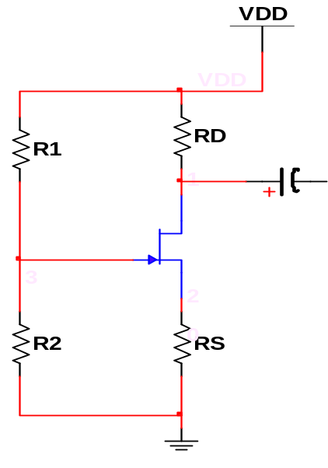  Vi  V0 | [6M]
 | b) | Analyze CS amplifier with Voltage divider bias and find the operating point. | [4M]
13. | a) | Derive an expression for frequency of oscillations of Hartley Oscillator. | [5M]
 | b) | Find the frequency of oscillations of a transistorized Hartley Oscillator having L1=5mH, L2=5mH and C=0.01µF. | [5M]
14. | a) | Derive the equation for diode current. | [6M]
 | b) | A Germanium diode displays a forward voltage of 0.25V at 10mA at room temperature. Estimate the reverse saturation current. | [4M]
15. | a) | Derive the expression for Q-point coordinates for a CE configuration using collector base bias with emitter resistance. | [5M]
 | b) | Find the quiescent point for the circuit shown in the below figure.  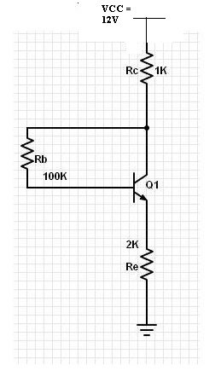 | [5M]
16. | a) | Derive expressions for current gain, input resistance and voltage gain of Common Emitter amplifier using small signal approximate h-parameter model. | [5M]
 | b) | Explain the operation of RC coupled amplifier with neat circuit diagram. | [5M]
17. | a) | Explain the operation of half wave rectifier with necessary waveforms. Derive V_{DC}, I_{DC}, ripple factor and efficiency for half wave rectifier. | [4M]
 | b) | What is thermal runaway and how it can be avoided? | [4M]
 | c) | Compare CE,CB and CC amplifiers. | [2M]
18. | a) | Explain why FET is called voltage controlled device. | [4M]
 | b) | What are the advantages of FET over MOSFET? | [4M]
 | c) | Explain the significance of Crystal oscillator. | [2M]

-- 00 -- 00 –

